Thank you for your interest in becoming a Capability Scotland Trustee. Please complete all sections of this application form. If you would prefer this form in a different format, please get in touch with us.
Please return this completed form to:
Susan McDonald Governance & Executive Assistant
Capability Scotland, Vantage Point, 24 St John’s Road, Edinburgh EH12 6NZ
Email: susan.mcdonald@capability.scot
Direct Dial: 0131 347 1023
Section 1: Your Details
Forename(s):
Surname:
Email:
Telephone:
Address:

Section 2: Employment & Experience
Please give details of any recent employment.
Please give details of any board or voluntary experience.

Section 3: About You
Why do you want to become a Trustee of Capability Scotland?

What skills or experience can you bring to Capability Scotland?

Please tell us about your education and qualifications, if applicable.
Institution | Qualification | Date Obtained

Have you ever been employed by Capability Scotland?
Do you have any relatives employed by Capability Scotland?

Do any of your relatives use our services?

Section 4: Disclosure Scotland
Capability Scotland conduct regular Disclosure Scotland checks. Trustees may, from time to time, meet customers and learners. Please give details of any Disclosure Scotland or PVG Scheme Membership you may have. Note that your scheme membership number is 16 digits long.
Are you a member of the PVG Scheme?
PVG Scheme Number:

Level of Check (if known):
Please note that Disclosure Scotland / PVG Scheme membership checks and regulatory registration body checks will be carried out by Capability Scotland.
Section 5: References
Please provide contact details for two referees.
 | Referee 1 | Referee 2
Referee Name:
Organisation:
Email Address:
Job Title:
Relationship to you:
Post Address:

Section 6: Disability Confident
Capability Scotland is proud to be a Disability Confident employer. We guarantee to interview anyone with a disability whose application meets the minimum criteria for the post. Do you consider yourself to have a disability and would like to apply under the Guaranteed Interview Scheme?
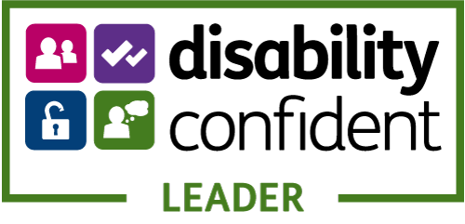

Section 7: Declaration
I certify that all the information contained in this form is true and correct, to the best of my knowledge.
Signature:
Print Name:
Date:

The legal grounds for collecting and processing information for Trustees, employees and volunteers, are that it is ‘in the legitimate interests of Capability Scotland’. We collect a variety of information from individuals and some of the information may be confidential and of a private nature. You have the right to object to your data being processed. You have the right to access the data we hold on you (by making a ‘Subject Access Request’), and to request it to be deleted or corrected. We collect data in a lawful way and always seek permission from individuals. You also have the right to make a complaint to the Information Commissioner’s Office (ICO), which is the regulator for data protection. Your information will only be shared with parties concerned otherwise it will be kept private.
A copy of our privacy statement is available under: Legal Statement & Documents | Capability Scotland

Thank you for your application.
We will be in touch soon.

Capability Scotland is a company limited by guarantee, registered in Scotland, number SC036524
It is a registered Scottish Charity, number SC011330.

